DEE AUTUMN HEAD

Saturday 26th October 2024

PARTICIPANTS INFORMATION

(INCLUDING LOCAL NAVIGATIONAL RULES AND REGULATIONS)

Contents

1 Important Information 2

1.1 Pre-Race (Cox and Steersperson) briefing 2

2 Safety 2

2.1 Officials 2

2.2 Club Responsibility 2

2.3 Other River Traffic 3

2.4 Cold Conditions - Hypothermia 3

2.5 Emergency Contacts 3

2.6 Alternative Arrangements 3

3 Event Timings 3

3.1 First Division 3

3.2 Second division 3

4 Organisation 4

4.1 Key Contact Information 4

5 Trailer Parking & Boat Assembly 4

5.1 The Groves 4

5.2 Queens Park High 5

5.3 Grosvenor RC 5

6 Visitors and Competitor Car Parking 5

7 Registration and catering 6

8 Boating 6

9 Start Assembly 6

10 Starting 7

11 Racing 7

12 After the race 8

13 Results and Medals 9

# Important Information

Please read this document in full some new information for this year’s competition has been included.

The Dee Autumn Head is a British Rowing (BR) Affiliated Event

The term “Participants” refers to anyone involved with the competition: Competitors, Coaches, Club Captains, Spectators.

Read Safety Plan and familiarise yourself with the Course Map. All documents can be found online on the Event Website, please familiarise with this information.

<https://www.grosvenor-rowingclub.org.uk/dee-autumn-head/>

## Pre-Race (Cox and Steersperson) briefing

Will take place at GRC The Cox briefing will be at 8am for the Morning division and 12pm for the Afternoon division There is a video, produced in 2021, which is still valid for this event. We advise that you watch this video in full in addition to attending the cox briefing

Link to the “Coxes Briefing Video” <https://youtu.be/VU4UcKoNL14>

# Safety

## Competing Club’s Responsibility

The race is held under the British Rowing Rules of Racing and British Rowing Guide to Good Practice in Rowing (Row Safe).

Please follow the instructions of the BR Umpires and Grosvenor Marshals who will act to ensure the safety and welfare of all at the event. Crews not following the instructions from the race officials may be disqualified by the race committee. All competitors, coaches and officials should ensure these instructions are read, understood and communicated to all participants.

Clubs should:

* Ensure crews are competent and capable of completing a 10km outing without putting others at risk and may be on the water in total for in excess of TWO hours.
* Inform the Organising Committee if competitors have any pre or existing health conditions, that may put them and other competitors at risk
* Request competitors not to lie back at the end of the race, as if they have collapsed (unless they have).
* Ensure Crews take sufficient warm clothing, gloves/hats on the water to avoid Hypothermia. A plastic bag is useful for placing clothing in during the course of the race to keep it dry.

## Other River Traffic

Crews should keep a look out for other river users as the river is not closed to other traffic when the race is on. The area of the course between the Red House and the Finish Line on the city side of the course will be used by large cruisers, they will not cross the centre line of the river.

IT IS YOUR RESPONSIBILITY TO KEEP A LOOK OUT.

Boats navigating to the start area should proceed up stream on the ‘Meadows Side’ of the river, i.e. keep to the bank cox’s right / sculler’s left. Boats may overtake on the way up, using the centre of the river, do not cross the centre line on the section between finish line and red house bend.

## Cold Conditions - Hypothermia

Coaches please advise your crews if they identify signs of Hypothermia, bring this to the attention of the Marshals or Umpires. Such as: shivering, slurred speech or mumbling, slow/shallow breathing, weak pulse, clumsiness or lack of coordination, drowsiness or very low energy, confusion or memory loss, loss of consciousness.

**Crews dressed inappropriately for the conditions may be prevented from boating.**

Provide Emergency Contacts

We are asking clubs to provide the contact details for responsible adults not racing in the same division. Who can be contact by mobile phone if their crew are involved in any incidents e.g. capsize or medical attention needed. This information should be provided via the ‘Competition Contact’ section in the entry for the crew in the BROE system.

## Alternative Arrangements

Sometimes the conditions are such that the event cannot safely continue as planned. It may then be appropriate to abandon or suspend the competition or make other alternative arrangements. In the run up to the event the organising team will be monitoring river levels, weather forecasts and warnings. If any adverse conditions are predicted for race day the impact assessed, any changes will be communicated to the entries contacts provided in BROE for the competing crews.

# Event Timings

First Division

|  |  |  |  |  |
| --- | --- | --- | --- | --- |
| Safety Briefing | Boating | Last crew past Red House | Last crew arrives at start area | Race Starts |
| 08:00 | Time and Landing Stage allocated on the Draw | 10.00 | 10:20 | 10:30 |

Second division

|  |  |  |  |  |
| --- | --- | --- | --- | --- |
| Safety Briefing | Boating | Last crew past Red House | Last crew arrives at start area | Race Starts |
| 12:00 | Time and Landing Stage allocated on the Draw | 14.00 | 14:20 | 14:30 |

Boating times have been provided in the draw, it is critical that these are followed to ensure safe navigation to the start area (mooring). The times are assigned to ensure safe assembly of crews in race order at the start area. Crews starting later will be boating later to reduce time waiting at the start. Late crews may receive a time penalty.

Respect the efforts of your fellow competitors, marshals and umpires and get to the start on time.

**A marshal will be positioned at (not) The Red House, 2 km upstream from the finish and will not allow any crew to proceed to the start who has not reached that point at least 30 minutes before the race start time.**

# Organisation

The Event is conducted under British Rowing's Row Safe, Rules of Racing and Adaptive Rowing Safety Guidance for Event Organisers.

Entries: use online BROE in accordance with the dates indicate on the event poster

## Key Contact Information

|  |  |  |
| --- | --- | --- |
| Chairman of the Race Committee (Race Control Main Contact & Coordinating Umpire) | Dan Clark | 07734 218788 |
| Event Chairman & Duty Officer | Debbie Knight | 07812 202794  deeautumnsec@gmail.com |
| Race Safety Advisor | Colin Davies | 07919 593049 |
| Welfare Officer | Jane Fellows | 07397 778366 |
| Entries Secretary | Brian Chapman | 07833 594700 |
| Timing Team Lead | Jeremy Lush |  |
| Pre-race Publicity/ Sponsorship | Charlotte Hill |  |
| Grosvenor Rowing Club | Land Line | 01244 311231 |

# Trailer Parking & Boat Assembly

There are two locations for parking boat trailers:

Visiting clubs will be allocated to a location, we do this to optimise the use of the landing stages. The event organising team will liaise with your entries secretary to allocate trailer parking.

## The Groves

Our main area is the Groves, near the bandstand and along past Hickories Bar.

Parking is restricted to boat trailers only along the Groves, the regular process we have operated for previous events is to move towing vehicles away from the Groves after the trailer is delivered. The area is monitored by traffic wardens during the event.

Due to the road closure on Souters Lane the standard parking rules advertised on the signage for parking bays do not apply on the event day.

Vehicles dropping off trailers and immediately moving away are ok to do so. This is the expected process. Sculling boat roof rack vehicles should also drop off and move away.

Boats may be assembled along the length of The Groves, however, plenty of space should be allowed for vehicles to pass through the Groves. Please avoid leaving boats opposite local business and domestic premises where vehicles access is needed. Please be aware this area is open to the public so take care when moving boats around.

Trailer access route information is a separate document available on Grosvenor RC website.

Marshals will assist you to park, note clubs boating from Grosvenor RC stage should park close to the bridge to avoid a long carry. Souter’s Lane has been closed specifically for trailer parking, the exit from the parking area is from the round-about near Hickories drive up the hill on Souters Lane to Chester road network.

PLEASE NOTE: NO PARKING OF TRAILERS OR VEHICLES ALLOWED ON COBBLES OR PAVED AREAS IN THE PUBLIC SEATING AND BANDSTAND AREA. THE DRIVER MAY BE ISSUED WITH A FIXED PENALTY NOTICE.

## Queens Park High

We have a few trailer spaces at Queens Park High School (CH4 7AE) via Queens Park Road. Please follow instructions from Marshals when parking vehicles and assembling/moving boats. Trailer access route information is a separate document available on Grosvenor RC website.

## Grosvenor RC

Grosvenor Rowing Club Location. The postcode for navigation is CH1 1SD. There is no parking available at the rowing club.

# Visitors and Competitor Car Parking

No car parking is available in the Groves & Souters Lane area due to the road closure for trailer parking, see the trailer parking information if you are towing or delivering equipment to this area.

Parking at Grosvenor Rowing Club on the day is reserved for Emergency Vehicles, Umpires, Deliveries and other Race Officials.

Car parking for visitors and competitors is normally available on roadsides in Handbridge, Queens Park High School open their car park on race day (£4). The Little Roodee car park is a short walk along the river from the Groves (£6) and there is parking on the Race Course.

# Registration and catering

Registration for ALL crews is in the main Grosvenor Rowing Club’s Boat House, on the first floor gym (right at top of stairs). Follow the one-way system to access this area

On arrival, crews should send a representative to Grosvenor RC to register at the entries desk, collect race numbers and confirm any substitutions with British Rowing card.

Numbers should be securely pinned to the back of the sculler or crew member in the bow seat and must be clearly visible during racing. Two number stickers supplied need to be fitted to both sides of the boat on the sax boards near the bow seat.

Hot drinks and food are available upstairs at Grosvenor RC.

Catering is also available at QPRC if your club is boating from their stage.

# Boating

Boating commences at the times specified on the Draw.

The draw indicates from where crews must boat. Crews boating in the Groves may use the two landing stages near the bandstand, or can boat directly off the promenade if the river is high enough. Blades and equipment should not be left on the promenade.

All stages will be under control of a Marshal. Although it’s your responsibility; boat safety life jackets and suitable clothing checks will be made on a random basis. Bow balls, heel restraints and/or buoyancy not up to standard will stop you boating.

Coaches and Athletes to shall ensure their boats and blades conform to Row Safe’s guidelines section 7.1 Equipment Checklist.

Random equipment inspections will be done with crews prior to boating. Marshals will be calling crews to boat at their allotted time and will be controlling the boating process.

ALL BOATS MUST HAVE A CLUB REGISTRATION ID ON THEIR BOATS, IF NO ID IS VISIBLE THEN AN AUTOMATIC TIME PENALTY WILL BE PLACED ON THE CREW.

# Start Assembly

Refer to the course map. There are marshalling areas – A,B,C and D. These will be marked on the Eccleston bank 75m upstream of the (A55 Bridge) start. Crews should refer to the race draw to find their marshalling area.

There will be Start Marshals both on the riverbank and in Launches to assist you. **Please don’t make it difficult by not knowing your number or what side of the river you are stationed refer to the Draw before you boat to know your parking location.**

Crews should proceed past the start i.e. the A55 Bridge, and remain bows pointing upstream and position themselves in numerical order in the relevant area as follows:

Crews will be assembled sequentially in race order as with approx. 50% of crews on each bank as follows the Draw will inform your crew which bank to moor on.

Crews should not turn until instructed to do so but be prepared if you see boats turning, Tops Off, Check Equipment, Stow Kit, Hydrate, etc.

# Turning & Starting

Competitors must obey the instructions of the Start Marshals at all times. When instructed to turn, boats should turn and paddle downstream lightly maintaining numerical sequence and 3 - 4 lengths of clear water. Crews will be started by the command "Number ...Go" approximately 50m from the ’Motorway Bridge’ (A55) start line. Timing will commence as each boat passes under the 'Motorway' bridge.

Overtaking is only allowed once boats have passed the A55 Bridge and Start.

All the crews on the Huntingdon bank will turn first and proceed to the start, once the Huntingdon bank crews have crossed the start the Eccleston bank crews will be instructed to turn.

# Racing and Hazards

All crews must comply with instructions of umpires.

In the unlikely event of unsportsmanlike behaviour this will be referred to the Organising Committee and Chief Umpire. Any disciplinary action will be in accordance with our Ruling Body’s Rules of Racing.

Heron Bridge Bend (ref course map) requires caution, for those boats equipped for straight line racing, may require a combination of both rudder and pressure to maintain the racing line.

The Starter will attempt to ensure that there is adequate space between boats at this stage of the race. Please also listen out for instructions from the Umpires and Marshals.

Boats being overtaken must give way in good time to allow faster boats to follow the racing (line) course. Failure to obey this request and other instructions from Umpires may result in a time penalty or disqualification. Time bonuses will not be awarded, penalties may. Complaints of interference must be registered with the Chief Umpire.

Coaches please, help the Umpires and instruct your coxes and scullers on Port and Starboard manoeuvres.

Crews should be aware of other river traffic not involved in the race. Once crews have passed the Red House restaurant (recently demolished, empty lot with diggers etc), all crews must race on the Meadows (cox’s left hand, scullers right hand) side of the river, avoid crossing the centre line of the river to avoid cruisers.

THE RIVER WILL NOT BE CLOSED TO OTHER CRAFT.

We have an agreement with larger commercial boats that they will use the City side of the river (when racing this is the side to the coxes right or bow steersperson left). Please be aware that other river users not connected with the race may be on the water and may not know the rules. The area of the course between the Red House and the Finish Line on the city side of the course is where they operate, they will not cross the centre line of the river. Stay to the meadows side of the centre line to avoid collision with the cruisers (when racing this is the side to the coxes left or bow steersperson right).

If you capsize or end up in the water any reason follow your capsize drill and stay with your boat. Draw attention from the umpires or marshals and wait for a safety boat to respond. Remember keep clear of the safety boat engine propeller.

# After the race

KEEP TO THE MEADOW’S SIDE TO AVOID MOORINGS ON THE CITY SIDE JUST AFTER THE FINISH. Follow the Circulation Pattern below.

The MARKED race finish is by the stone steps at the bottom of Dee Lane. There will be no signal. As soon as a boat has passed the finish line, competitors should wind down to light pressure and continue paddling. DO NOT STOP ON THE FINISH

Returning to the landing stages. Boats should continue on the Meadows (cox’s left / scullers right) side of the river from this point, down towards the Turning Buoy and Suspension Bridge.

Follow the instructions from the marshalling launch in the finish area.

Crews returning upstream to Kings RC, Grosvenor RC, Royal Chester RC and Queens Park Rowing Club may be directed to turn before they reach the turning buoy and proceed back to their stages on the City/ Grosvenor side of the river. Crews returning to QPRC should follow the boating pattern and cross over to their stage as and when it is safe to do so avoiding finishing crews.

Crews returning to the Groves/Bandstand should turn and paddle to the landing stage as they pass under the Suspension Bridge approaching the landing stages upstream.

Crew members should disembark immediately and move the boat alongside the stage to allow following boats to do the same.

Failure to comply with the above rules may put other boats at risk and will render crews liable to disqualification or a time penalty, as may be deemed appropriate.

Below the Suspension Bridge there is a weir, highlighted by three yellow buoys, keep clear of this area and the large moorings, gauge the stream and once under the suspension bridge turn, do not leave it too late as you may drift towards these hazards.

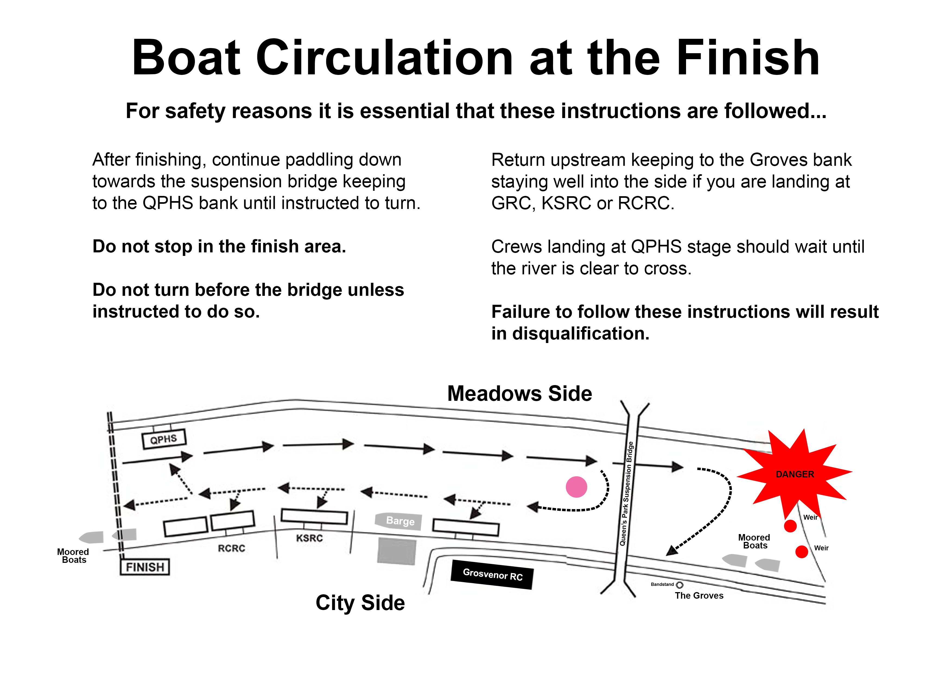

# Results and Medals

Provisional results will be posted at Grosvenor RC and QPRC as soon as possible and copies will be distributed as soon as possible. Results will also be posted after the event on the Grosvenor RC website <http://grosvenor-rowingclub.org.uk/about-us/dee-autumn-head/>

Appeals with respect to timings must be made to the Race Committee immediately after publication of results.

Medals will be presented and may be collected from the Entries desk immediately after the results have been published.

BE SAFE AND HAVE AN ENJOYABLE AND SUCCESSFUL EVENT